**Transaction Analyzer UI screenshots for reference**

* Enter the application url

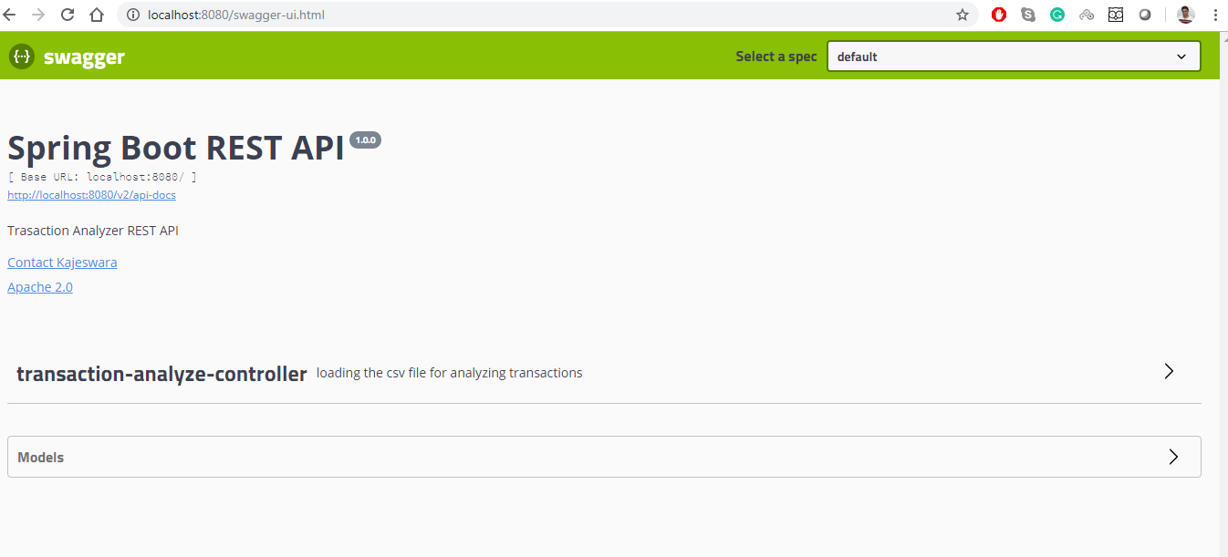

* Click on transaction-analyze-controller, will display post uri to access parameters.

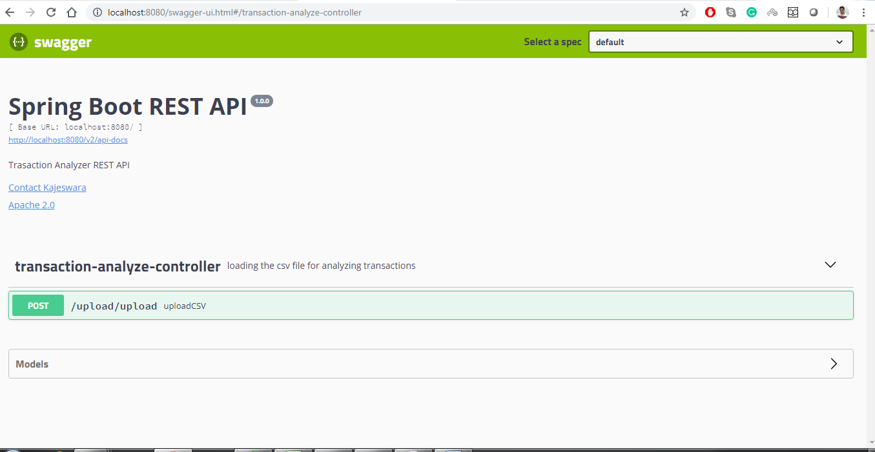

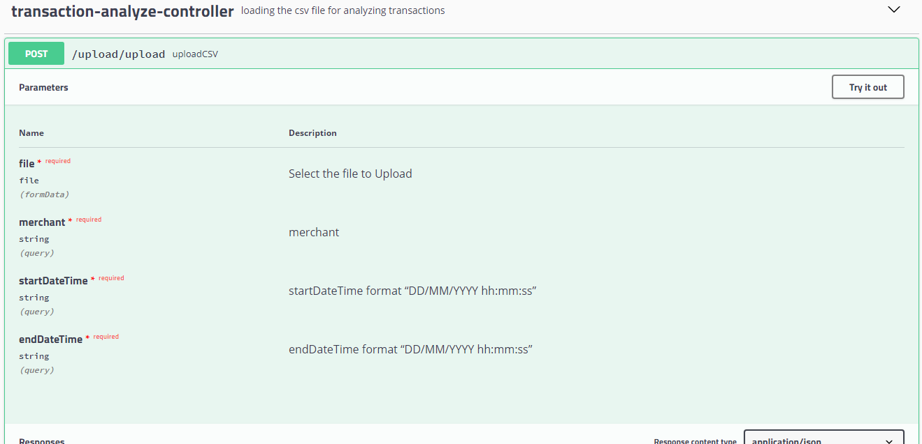

* Click on try it out button to give input for the corresponding parameters.

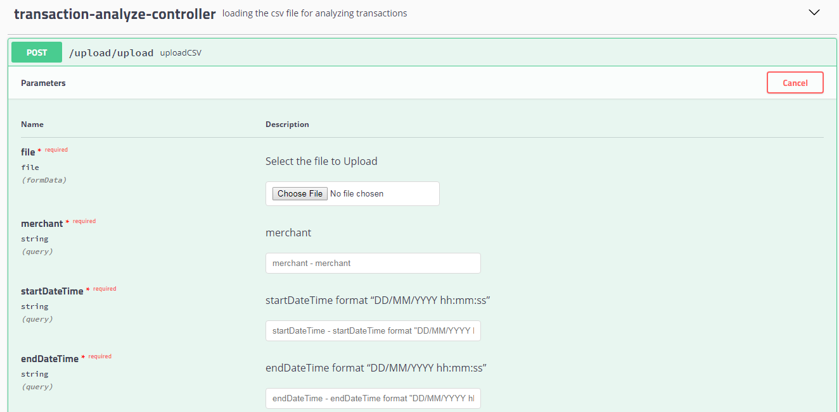

* Once entered the all input parameters then click on Execute button to get the response details.

